EXAMPLES AND CASE STUDY EXAM PRACTICE
GCSE GEOGRAPHY
PAPER 1 & 2

Aim for Excellence

Name:
Class: Teacher:

Use this Page to understand the ‘command words’
Too many people miss out on marks because they did not understand what the question was asking them to do. Make sure you know what your command words mean. These are the words that tell you what to do.

Paper 1: Living with the physical environment
Section A – The challenge of natural hazards
Specification | Example/Case Study
Use named examples to show how the effects and responses to a tectonic hazard vary between two areas of contrasting levels of wealth | Haiti 2010 (LIC) and Christchurch, New Zealand 2011 (HIC)
Use a named example of a tropical storm to show its effects and responses | Typhoon Haiyan (2013)
An example of a recent extreme weather event in the UK | Somerset Levels

Section B – The living world
Specification | Example/Case Study
An example of a small-scale UK ecosystem | Woodland (Epping Forest, London)
A case study of a tropical rainforest | The Amazon Rainforest, Brazil
A case study of a Hot Desert | Western Desert
A case study of desertification | The Sahel in Africa

Section C – Physical landscapes in the UK
Specification | Example/Case Study
An example of a section of coastline in the UK | Dorset Coast, near Swanage, South East England.
An example of a coastal management scheme in the UK | Holderness Coastline, Mappleton
An example of a river valley in the UK to identify its major landforms of erosion and deposition | River Tees
An example of a flood management scheme in the UK | Banbury Flood Management Scheme

The challenges of Natural Hazards Topic

Comparison of a tectonic event in an LIC & HIC
Case Study Section | LIC Haiti 2010 | HIC Christchurch 2011, New Zealand
Location | On the 12th January 2010 a 7.0 magnitude earthquake struck the Caribbean island of Haiti. | The 6.3 magnitude earthquake struck New Zealand at 12:51 on 22 February 2011. The epicentre was 6 miles South East of Christchurch and the focus was very shallow at 5KM.
Causes | The earthquake occurs at a destructive plate margin between the Caribbean and North American Plate, along a major fault line. The earthquake focus was 13km underground and the epicentre was 25km from the capital Port-au-Prince. There were a large number of serious aftershocks after the main earthquake | The earthquake occurred on a conservative plate margin where the Pacific Plate slid past the Australian Plate in the opposite direction. It was technically an aftershock from a larger earthquake in 2010 but the impacts were more severe.
Short term/Primary Effects | 230,000 people killed and 300,000 injured. The main port was badly damaged, along with many roads that were blocked by fallen buildings and smashed vehicles. Eight hospitals/health centres in the capital collapsed or were badly damaged. Many government buildings were also destroyed including the Presidential Palace. About 100,000 houses were destroyed and 200,000 damaged | 181 people were killed and 3,129 people injured.  3.5 m tsunami waves in Tasman Lake, following quake-triggered glacier calving from Tasman Glacier  Hundreds of kilometres of water and sewage pipes were damaged  50% + of Central City buildings severely damaged including the city’s cathedral which lost its spire  Liquefaction (where the ground gets saturated and loses strength) caused lots of damage to roads and buildings  Part (size of 20 football fields) of the country’s longest glacier was broken off creating a large iceberg  80% of the city was without electricity
Long term/Secondary Effects | Around 1.3 million Haitians were displaced (homeless) and over 2 million were left without food and water. Looting became a serious problem. The government struggled to control Haiti and the police force collapsed. The damage to the port and roads meant that critical aid supplies for immediate help and longer-term reconstruction were prevented from arriving or being effectively distributed. Displaced people were set up in temporary shelters and tents, where many lived for over a year, which led to diseases. A cholera outbreak killed hundreds of people in November 2010. Services such as electricity, water, sanitation and communication were badly damaged resulting in frequent power cuts. The many dead bodies in the streets and under the rubble, created a health hazard in the heat, so many had to be buried in mass graves | Business were put out of action for long periods causing losses of income and jobs.  Schools had to share classrooms because of the damage to other school buildings.  An additional 1,293 people were injured in the aftermath  Damage to roads through liquefaction made it difficult for people and emergency services to move around.  People were affected mentally by the earthquakes and needed support.  Christchurch could no longer host Rugby World Cup matches so lost the benefits, e.g. tourism and income, they would bring.
Short term responses | Crucial aid (food and medical supplies) were slow to arrive due to the damage of roads and port. The airport couldn’t handle the number of planes landing. American engineers were used to clear the worst debris and get the port working again, so aid could arrive. The USA sent ships, helicopters and 10,000 soldiers, search and rescue teams and $100 million in aid. The UN sent troops and police and set up a ‘Food Aid Cluster’ to feed 2 million people. Bottled water and water-purification tablets given to survivors. Field hospitals were set up, and helicopters flew injured people to nearby countries. The Haitian government moved 235,000 people from the capital to other less-damaged cities | Cared for the most vulnerable people and ensured people were safe from dangerous buildings.  Chemical toilets were provided for 30,000 residents.  The government declared a state of national emergency, which stayed in force until 30 April 2011.  Rescue crews from all over the world came to help. There were crews from Japan, the United States, the United Kingdom, Taiwan, Australia and other countries.  Domestic help was available - The Farmy Army was made up of 800 farmers who brought their farm machines and muscle to help clean up the city.  International aid was provided in the form of money (around $6-7 million) and aid workers.
Long term responses | Haiti was dependant on overseas aid to help its recovery, the World Bank pledged $100 million. New homes were to be built to a higher standard costing billions of dollars. Large scale investment needed in services and infrastructure. The recovery was extremely slow, with over 1 million people living were still living in temporary shelters. Several thousand people moved away from Port-au-Prince for good, often emigrating to other countries. | Paid $898 million in building claims.  Provided temporary housing and ensured all damaged housing was kept water tight.  Water and sewerage was restored for all residents by August.  Roads and houses were cleared of silt from liquefaction by August and 80% of roads/50% of footpaths were repaired.  Many Non-government organisations including Save the Children helped with long term recovery efforts  Canterbury Earthquake Recovery Authority was created to organise the REBUILD of the region.

Tropical Storm: Typhoon Haiyan
Causes
Tropical storms have strong winds and torrential rain. They are circular in shape and can be hundreds of km wide. They form over tropical seas (27oC or higher). Warm moist air rises and condenses. This releases energy which makes it grow really powerful. They lose strength as they move over land because their energy source (warm water) is cut off.
Typhoon Haiyan hit the Philippines in November 2013. It was known as a super typhoon, being category 5 on the Saffir Simpson Scale. It was one of the largest storms ever recorded. Huge areas of coastline and several towns were devastated by winds of 170mph and waves as high as 15m (storm surge). The large scale flooding worsened the impacts of the storm and the government were criticised for a slow response.
Primary effects
- 6300 deaths – most drowned by storm surge.
- 90% of Tacloban city destroyed (the worst hit).
- 40,000 homes damaged.
- Tacloban airport severely damaged.
- 30,000 fishing boats destroyed
- Crops and farmland destroyed
- Widespread flooding due to storm surge.
- $12 billion cost in total.

Secondary effects
- Millions made homeless – 4.1 million in total.
- 6 million lost their source of income (e.g loss of fishing and farming industry).
- Ferry services and flights disrupted for weeks slowing down aid support.
- Looting and violence broke out in Tacloban.
- Shortages of water, food and shelter led to outbreaks of diseases.
- Flooding caused landslides.
- Remote communities cut off as landslides caused roads to become blocked.
- Some areas lost power for months as power lines were destroyed.

Responses- short term/immediate & long term
Short term
- 800,000 people evacuated following a televised warning.
- 1200 evacuation centres set up to help the homeless.
- Search and rescue
- 3 cays after, airport reopened and emergency aid was provided.
- International aid agencies provided food aid, water and shelters.

Long Term
- Rebuilding of roads, bridges and airports faciltiies.
- ‘Cash for work’ programmes – people paid to help clear debris ans rebuild city.
- Thousands of homes rebuilt from areas at risk of flooding in preparation for future storms.
- More cyclone shelters built to accommodate people evacuated from coastal areas.
- Over 1000 people were rehomed into caravans/trailers outside of the city. Although this was only supposed to be short term many residential areas were left reunited and as a result people accepted these as their new homes.
- Ove months, Oxfam helped replace fishing boats to re-establish the fishing industry.

The levee was rebuilt and designed to be taller and stronger than before. Areas of land around the levee are now restricted from future development in order to reduce the future effects of another storm.
Somerset levels 2014
The Somerset levels are an extensive area of low-lying farmland and wetland bordered by the Bristol Channel and Quantock Hills to the West, and the Mendip hills to the North.
The area is drained by several rivers, most notably the Tone and the Parrett, which flow in to the Severn estuary via Bridgewater.

Reasons for the flooding
-Wettest January in the area since 1910 - area of low pressure sitting over head.
- Area received 100mm above average rainfall over January and February in 2014.
-Very flat area
-Area is drained by a number of rivers which flow into the River Severn.
- Rivers had become clogged with mud and debris, which meant there was less room for rainwater

Effects/impacts of the flood- Social/Economic/Environmental
- 600 homes flooded.
- 16 Farms had to be evacuated and huge sums of money was lost due to damaged machinery and crops
- The Bristol and Taunton railway had to close meaning people could not commute to work.
- 2 Villages were completed cut off with children having to leave via boat to get to school.
- Many people had cut off power supplies for days.

Other evidence for extreme weather in UK
- Beast from the East (2018) – Blizzard
- Increasing number of heatwaves – e.g Summer 2022 had a record temperature of 40.3 degrees Celsius

The Living World Topic

Epping Forest, East London, UK

Location
Epping Forest is located in North East London and is an ancient deciduous woodland. It has many native trees including oak, ash, elm and beech. There is a lower shrub layer of grasses, brambles and bracken that form the main producers in the ecosystem. There are many birds, mammals, amphibians and insects which are the consumers. Over 700 species of fungi act as important decomposers for the ecosystem.

Interrelationships in the Ecosystem
Season | Ecosystem Interrelationships: deciduous trees
Spring | Flowering bulbs such as bluebells make use of the sunlight penetrating through branches. The stored nutrients are used by the growing plants (producers)to produce fruit, berries and nuts that will feed consumers.
Summer | The broad tree leaves grow quickly in the Spring. With a large surface area, they maximise the Sun’s energy to photosynthesise.
Autumn | To conserve energy and moisture, the trees shed their leaves. This is a direct response to the UK climate as the temperatures and sunlight hours decrease towards winter.
Winter | Bacteria and fungi decompose the leaf litter, releasing the nutrients into the soil.

Producers, Consumers and Decomposers
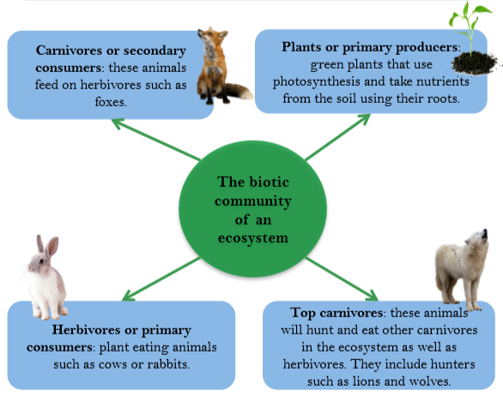

Food Chains and Food Webs
A food chain shows the direct links between organisms in an ecosystem, in the form of a line whereas a food web shows all the connections between organisms in an ecosystem. Below is an example of a food web for Epping Forest.

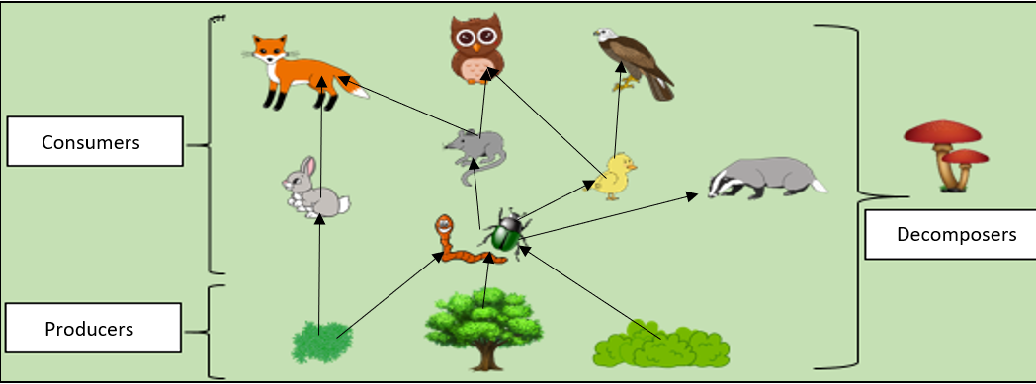

An example of a food chain would be:

Deciduous Tre insects small bird sparrowhawk

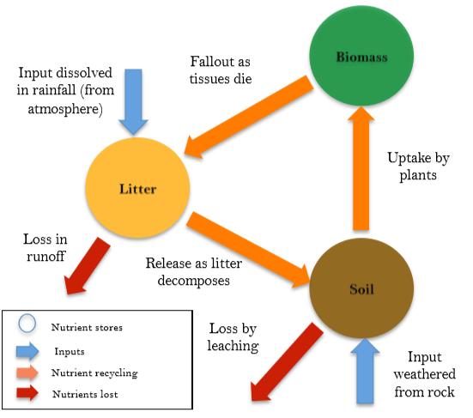
Nutrient Recycling
The balance and interdependence between the components of the deciduous woodland ecosystem can be demonstrated by the nutrient cycling that takes place.

Inputs in to the ecosystem include weathered rock which forms soils, some of this soil is lost through leaching (rainwater washing the nutrients) and some of the soil is taken up by plants (biomass). Biomass takes up the nutrients in the soil, when the biomass dies its tissue falls to the surface to form the litter. Decomposers break down the tissue in the litter and release organic matter back in to the soil where the nutrients can be taken up by biomass again. The cycle is continuous.

The Amazon Rainforest, Brazil, South America

Location
Tropical Rainforests are found in over 60 countries in the world. The Amazon Rainforest is in South America and covers 2.1 square miles of land across many different countries. If the Amazon Rainforest was a country, it would rank 9th in size. The greatest concentration of tropical rainforest in terms of biomass is in Brazil, Brazil has about 480 000 hectares of rainforest and is home to 60% of the Amazon Rainforest with neighbouring Peru home to 13% and Colombia; 10%. Venezuela, Ecuador, Bolivia, Guyana, Suriname and French Guiana have very small parts within their borders.

Biodiversity in the Amazon Rainforest
The Amazon Rainforest is home to 10% of the known species in the world. It has 205 species of birds, 40 000 plant species and 2.5 million insect species. There are approximately 3 000 fruits that grow in the rainforest that are edible. There are approximately 10 million species of animals, plants and insects known to man and more than half of them call the rainforest home. Many plants around the world have medicinal qualities. Of the plants known to have anti-cancer properties, 70% are found in the rainforest. Amazon natives use rainforest plants regularly but 90% of the ones they use have not been studied by modern science.

Causes of Deforestation in the Amazon Rainforest
In the last 100 years, the impact of deforestation on tropical rainforests has become serious. The United Nations Food and Agriculture Organisation (UNFAO) estimate that around half of the world’s tropical rainforests have now been deforested.

The rate of deforestation has fallen in Brazil to a record low. It is estimated that around 50% of Brazil’s remaining rainforest now has some form of protection status. However, 20% of the Amazon rainforest has now been cleared since 1970; that’s an area of 761,000 km² (about three times the size of the UK).

There are several causes of deforestation in the Amazon. These are:
- Agriculture
- Logging
- Road Building
- Mineral Extraction
- Energy Development
- Settlement and Population Growth

Cause of Deforestation | Description
Agriculture | Indigenous rainforest tribes practise subsistence farming. However, land is increasingly cleared for commercial farming – crop plantations and cattle grazing.  In Brazil, cattle ranching accounts for 80-90% of deforestation. In Brazil, soybeans, palm oil and sugar cane (for biofuel) are major crops.
Logging | Logging is the first step in the conversion of forest land to other uses. This may seem surprising giving that logging only accounts for 3% of the causes of deforestation in Brazil. This is because it is the eventual use of the cleared land is put to that is recorded in the pie chart. Trees such as mahogany and teak are highly valued (selective logging) for furniture and other uses. Smaller trees are used for fuel, pulped or made in to charcoal. Vast amounts of the rainforest are cleared in one go (clear felling). There is also lots of illegal logging.
Road Building | Roads bring supplies and provide access to new mining areas, new settlements and new energy projects.  In Brazil, the Trans-Amazonian Highway stretches for some 4 000 kilometres through the rainforest. This is accounted for in the 2% other category of the causes if deforestation in Brazil.
Mineral Extraction | Mineral extraction such as gold mining fall into the other category that accounts for 2% of the causes for deforestation in Brazil. In 1999, there were 10,000 hectares of land being used for gold mining. Today, there is over 50,000 hectares of land being used for gold mining. The rainforest also suffers from bauxite extraction which is used to make aluminium.
Energy Development | Also, included in the other category is energy development. An unlimited supply of water and ideal river conditions have encouraged dams to be built to generate hydroelectric power (HEP). This involves flooding vast amounts of rainforest. Often, the dams have a short life. In Brazil, the Belo Monte Dam will block the Xingu River flooding more than 40 500 hectares of land and displacing 15 000 people. The submerged forest eventually rots, making the water very acidic which then corrodes the HEP turbines. The dams also become blocked with soil washed down deforested slopes by the heavy rain.
Settlement and Population Growth | Population growth and migration to the area is also putting pressure on the Amazon rainforest, especially as the Brazilian government offers land in the rainforest to poor people from overcrowded cities. Many people migrate to the rainforest for work in the industries mentioned above. In turn, this means that land needs to be cleared to make way for settlements where workers and their families can live.
Impacts of Deforestation in the Amazon Rainforest
There are many consequences or impacts of deforestation, whilst two are of global significance, the others are essentially local.

Impact of Deforestation | Description
Soil Erosion | Soil takes thousands of years to form, but it can be stripped away in a matter of hours. Removal of soil by wind and rain is called soil erosion. The roots of trees and plants bind the soil together. As soon as any part of the rainforest is cleared, the thin layer of topsoil is quickly removed by heavy rainfall. Bare slopes are prone to soil erosion. Once the topsoil has been removed, there is little hope of anything growing in that area again. Soil erosion also leads to the silting up of river courses. Even when the soil is protected, it quickly loses the little fertility it has when covered by trees. Grazing and plantations do little if anything to keep the soil fertile. The decline in soil fertility leads to pastures and plantations being abandoned, so more areas of the rainforest are cleared.
Loss of Biodiversity  (Global) | Biodiversity is a measure of the variety of plants and animals in an ecosystem. Rainforest are the most biodiverse ecosystem in the world. Clearing tropical rainforests means that the biodiversity will be reduced, and individual species will become endangered and trees possible extinct. It has been estimated that 137 plant, animal and insect species are being lost each day due to deforestation. This amounts to 50, 000 species each year. As the rainforest species disappear, so do many cures for life-threatening diseases. Currently, over 120 prescription drugs sold worldwide come from plant sources. 25% of the active ingredients in today’s cancer-fighting drugs come from the organisms found only in the rainforest. Recent research has shown that the Amazon rainforest could lose between 30 and 45% of their main species by 2030.
Climate Change  (Global) | Climate change is amongst the significant global impacts of deforestation in the rainforest. During photosynthesis, the tree canopy absorbs carbon dioxide (a greenhouse gas) in the atmosphere which reduces the rate of climate change. The Amazon stores around 100 billion tonnes of carbon. When the trees are felled, this stops, and more carbon dioxide remains in the atmosphere. Fire is often used to clear the rainforests, this means that the carbon stored in the wood is released back into the atmosphere where it will absorb heat and increase Earth’s climate. Deforestation is responsible for at least 15% of global CO₂ emissions each year – more than all the world’s transport emissions combined. In addition, trees give off moisture from the process of transpiration; deforestation reduces the moisture in the air resulting in a drier local climate. With less moisture comes less condensation and in turn rainfall. The natural recycling of water is like a cooling system, once the recycling is reduced (through less moisture) the local climate becomes warmer. Increasing dryness and rising temperatures are not good for people or activities such as agriculture.
Economic Development | Deforestation in many parts of the world is driven by profit. Deforestation may lead to short-term economic gains, but it may also lead to long-term economic losses. The natural rainforest has brought wealth to countries that were poor. Agriculture makes a lot of money in the rainforest. In 2008, Brazil made $6.9 billion from trading cattle, Brazil is also the world’s second biggest exporter of soy bean. The mining industry creates jobs for local people, for example the Buenaventura mining company in Peru employs over 3100 people. Logging contributes a huge amount to Brazil’s economy. Companies will pay taxes to the government which can be used to improve public service such as education, healthcare and water supply. However, in the long-term, deforestation can destroy the resources that countries depend on such as timber and non-timber products, tourist numbers may also decline as the area reduces in attractiveness. The livelihoods of some local people are destroyed as deforestation can cause a loss of animals or plants that they rely on to make a living. For example, local Brazilian rubber tappers who extract natural rubber from rubber trees have lost their livelihoods as trees have been cut down.

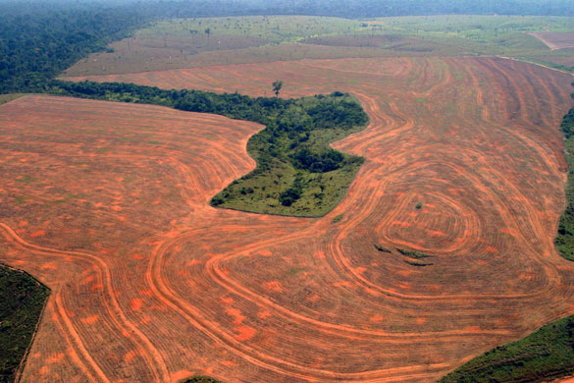

Economic Losses and Gains
Deforestation in many parts of the world is driven by profit. Deforestation may lead to short-term economic gains but it may also lead to long-term economic losses. The natural rainforest has brought wealth to countries that were poor. Agriculture makes a lot of money in the rainforest. In 2008, Brazil made $6.9 billion from trading cattle, Brazil is also the world’s second biggest exporter of soy bean. The mining industry creates jobs for local people, for example the Buenaventure mining company in Peru employs over 3100 people. Logging contributes a huge amount to Brazil’s economy. Companies will pay taxes to the government which can be used to improve public service such as education, healthcare and water supply. However, in the long-term, deforestation can destroy the resources that countries depend on such as timber and non-timber products, tourist numbers may also decline as the area reduces in attractiveness. The livelihoods of some local people are destroyed as deforestation can cause a loss of animals or plants that they rely on to make a living. For example, local Brazilian rubber tappers who extract natural rubber from rubber trees have lost their livelihoods as trees have been cut down.

Dessert Opportunities & Opportunities: The Western Desert- USA

Location
The Western Desert is a region in western USA, which is made up of 4 different deserts. This area covers a number of states including California, Nevada, Arizona, New Mexico, Texas and Utah.

Opportunities for Development
Opportunity for Development | Description
Mineral Extraction | In the past the Western Desert was a key part of the American Gold Rush in the 1800. Although there is still gold found within the desert much of it has now been mined and sold. Other minerals commonly mined today are other high value metals such as copper. The mining industry has provided hundreds of local jobs in Arizona and helped the local economy grow.
Energy | The strong insolation in desert regions provides a fantastic opportunity for solar power. The entire Western Desert region is predicted to benefit from the construction of new solar power plants. The Sonoran Solar project in Arizona is a new solar power plant project that will ultimately produce energy for 100,000 homes and requires 360 workers to help build it.  Hydroelectric power (HEP) plants also supply Western Desert communities with some of their electricity. These are powered by water leaving Lake Mead. At the peak of its construction in the mid-1930s, the Hoover Dam employed 5000 people.  Fossil fuels bring opportunities to the Western Desert too. People have been drilling oil in Arizona since 1905. Today there are 25 active oil production sites, all of which are on land owned by the Navajos people. Since 1998, the Navajo Nation Oil and Gas Company (NNOGC) has exploited this economic opportunity for the benefit of local Navajo people. More than 100 employees work to produce oil worth US$50 million.
Farming/Agriculture | Crops/arable farming in the Western Desert accounts for 15% of all Americas crop production. The warm climate and sunny skies make it an ideal situation for food production. They do however rely on a large amount of water. This is managed through irrigation using 2 methods-  - Aquifers: large stores of water lie beneath some hot desert regions. Sometimes a layer of permeable rock lies on top of impermeable rock. Rainwater and groundwater seep into the permeable layer and become trapped. This water can be brought to the surface by digging a well. Despite being part of the Sonoran desert, aquifer-based farming in California’s Coachella Valley produces lush crops of vegetables, lemons, peppers and grapes (and in turn- a wine industry.)  - Canals: most canals are used for large-scale industrialised agriculture. Farmers are allocated 80% of Colorado water, even though they make up just 10% of the economy. Water is carried from rivers in these canals to nearby farmland.
Tourism | As US society has grown to have more money and leisure time, tourism has become the Western Desert’s most important source of income:  - The national park offer visitors a chance to experience a wilderness area. Important areas include the grand canyon and California’s Joshua tree national park (names after its dominant plant type)  - The heritage and culture of native Americans are celebrated at the Colorado Museum in Parker, Arizona.  - The entire economy of Las Vegas is built around entertainment, attracting 37 million visitors per year.  - Two major lakes have been created as part of water management projects: Lake Mead and Lake Powell. Combined, they attract two million visitors a year and offer sailing, power boating, water skiing and fishing.

Challenges that hinder Economic Development
Challenges for Development | Description
Extreme Temperatures | Deserts can easily reach to temperatures of 40 degrees and higher in the day making them dangerous places to be. In 2015 a man died from dehydration in the Western Desert after his car broke down.  With limited vegetation there is limited shade. The constant high pressure has increased the risks of skin cancer and sunstroke.
Population Growth | With a rapidly growing population the Western Desert is under threat of depleting its water supply and drying the Colorado River. The population is set to double by 2050.  It also means that areas like Las Vegas can gain a large amount of capital from the millions of tourists that visit every year. About 40 million people come to visit every year now, bringing in over $100 million. This helps with the country’s economy and combat energy and water management.
Water Supply | A decreasing rainfall due to climate change has meant that reservoirs are not being recharged e.g. Lake Mead reached a record low in 2014.  An international agreement states that the water must be allowed to flow into Mexico supplying the north of the country with fresh water. As a result the south west is limited on the amount they can use.  Agriculture: 15% of the USA’s crops and 13% of all live stock are farmed around this stretch of the Colorado River meaning large amounts of the water is needed to irrigate (water) the land. However this does bring a lot of money into the area, which can be invested in water security.  With a population of 30 million the south west of the USA, this puts a lot of pressure on water supplies. The areas survives off the Colorado River, which carries melt water from the Rocky Mountains.  The river has been dammed in several places to store water for major cities e.g. the Hoover Dam for Las Vegas. As well as this, aqueducts have been used to carry water further to other cities such as Phoenix costing $4 billion.

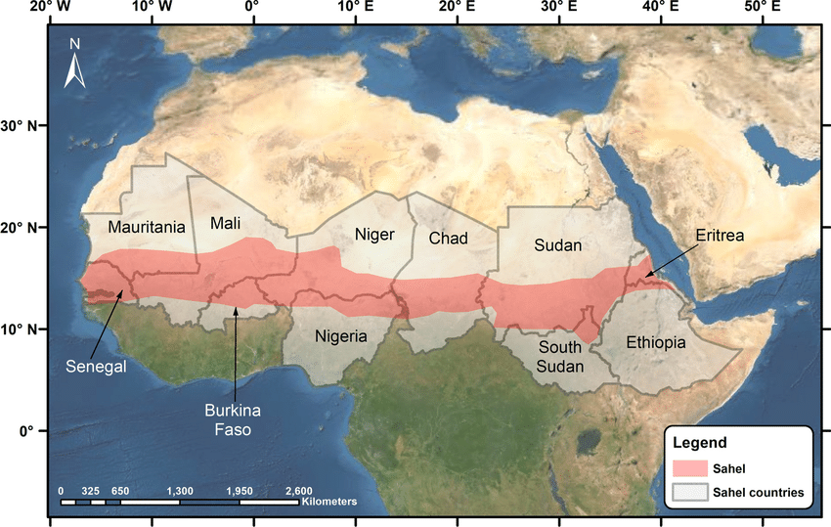
Desertification in the Sahel: Causes
The Sahel is a region of semi-arid land that stretch from west to east Africa. The region lies between the Sahara in the north and the rainforest in the south. The areas covers some of the World’s poorest nations.

Deforestation: Over the years, trees have been cut down for building material and fire wood. As a result there are less roots to retain moisture in the soil and bind the soil. Over time the soil has dried up and blown away through the process of soil erosion.
Changes in rainfall: Over the last 100 years, the area has received less and less rainfall. This has reduced the amount of nutrients in the soil, causing the soil to dry up and erode away. Both of these process are slowly turning the land into desert.

Planting Trees/Afforestation
Managing desertification in the Sahel
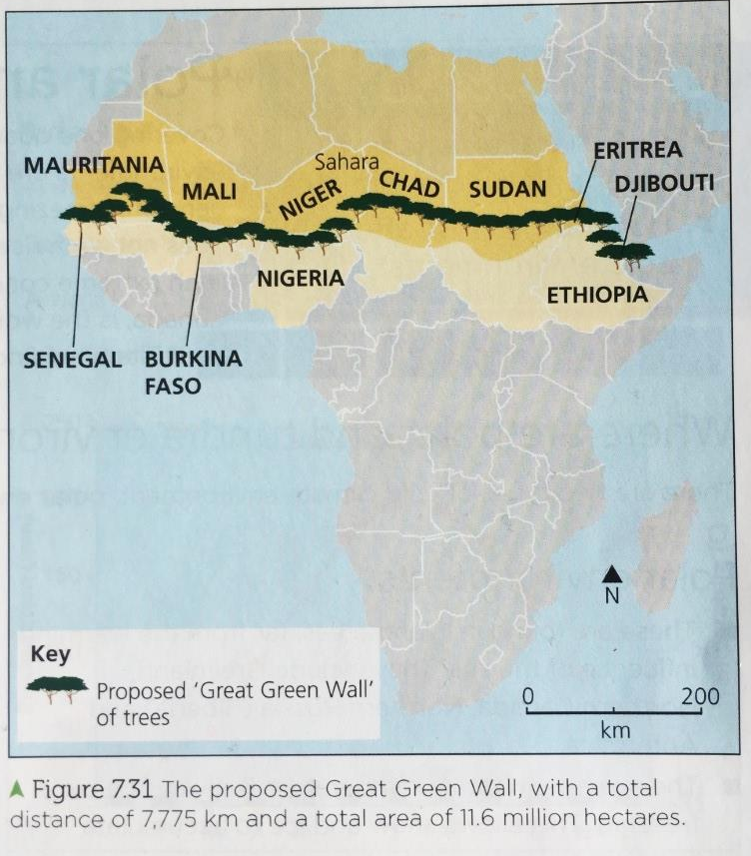
Disadvantages

It will be decades before it reaches maturity and stabilises the soil.
Climate change predictions suggest aridity may threaten the survival of the trees.
It is expensive. Its success also relies heavily on all countries doing their part.

Tree roots help to stabilise the soil, while their decomposing lead litter adds valuable nutrients
So what are they going to do? Just plant more trees anywhere?

The African Union’s proposed Green Wall is a plan to plant a wall of trees across the entire Sahel region, running from the Atlantic Ocean to the Indian Ocean.
It offers hope for sustainable development among communities, and will bring work to poor communities.

Bunds
One successful strategy, introduced in the Sahel countries of Mali and Burkina Faso, is the construction of low stone walls called bunds.

The stones are planted in lines parallel to the slope gradient. They help to prevent soil erosion, and slow down the flow of rainwater over the baked ground.
When water pools behind a bund instead of running fast over the land, it has time to soak into the ground.

The extra moisture helps prevent the soil eroding away by the wind.
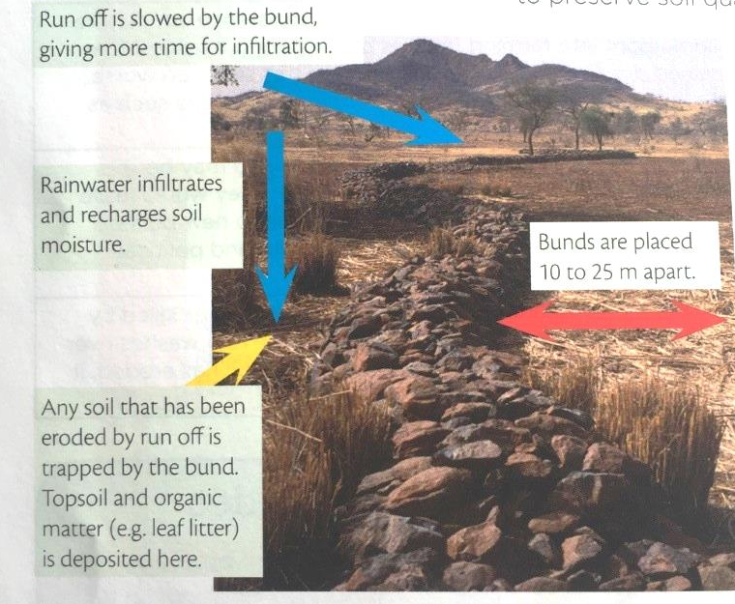

Solar Cookers
This is a form of appropriate technology as it’s cheap, requires low skills and is easy to use.
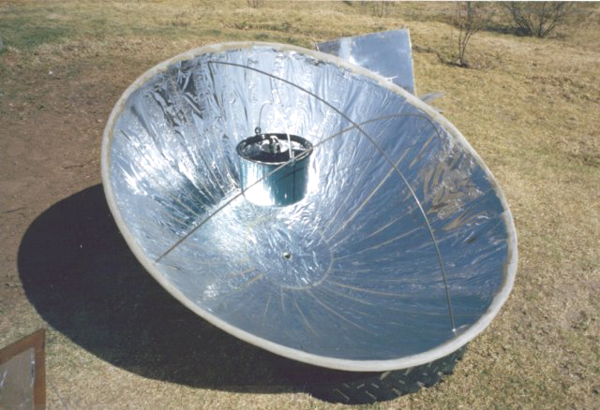
This method does not directly tackle desertification but tackles it indirectly.

This is because solar cookers rely on the heat of the sun only, meaning people do not need to cut down trees to get firewood.

This allows trees to remain in the ground holding the soil in place, avoiding erosion. This is effective as fire wood is the number one cause of deforestation in the Sahel.

This is a suitable form of intermediate technology as the method is cheap, needs little education and due to the abundance of sun light in the Sahel the method is very efficient. However the method is not available in all countries within the Sahel and cannot be used at night. As a result many people still use firewood at night.

Physical landscapes of the UK

Dorset Coast, near Swanage, South East England

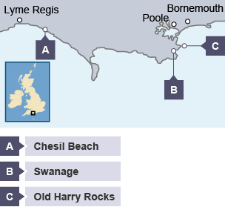
Location
Dorset is in the south of England. Its coastline has examples of many erosional and depositional landforms.
For example:
- Swanage is an example of a headland and bay
- Old Harry Rocks is an example of caves, stacks and stumps
- at Chesil Beach there is a bar

Swanage Bay
The area around Swanage is made up of bands of hard and soft rock. The soft rock is made of clay and sands, and the hard rock is chalk and limestone. As erosion processes take place, the clay erodes away quicker than the limestone and chalk. This forms headlands and bays creating Swanage Bay and two headlands - Ballard Point and Durlston Head.
To the north of Swanage is Poole Harbour, one of the UK’s largest natural harbours. A great deal of deposition has taken place in this large sheltered bay. You can see two spits at the mouth of the harbour, one on the south side and one on the north.
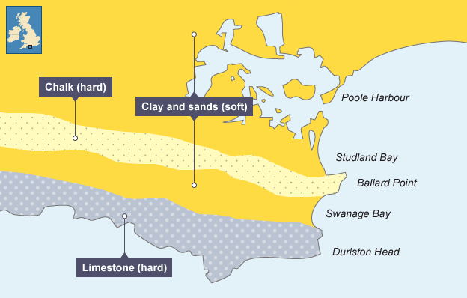

Old Harry Rocks
Old Harry Rocks are located on the headland between Swanage and Studland Bay. The headland is made from chalk, a hard rock. The headland juts out into the sea, so it is more vulnerable to high-energy waves. This caused the formation of Old Harry, a stack. Over time Old Harry will collapse to form a stump.

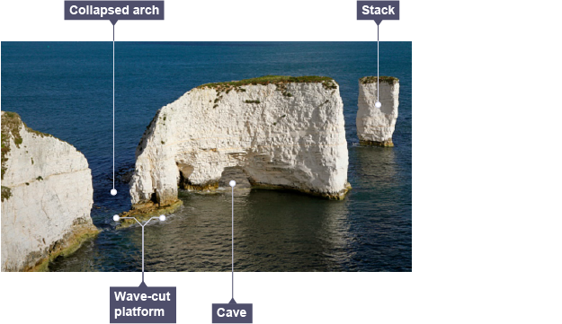

Chesil Beach
Chesil Beach is an example of a bar. Sediment has been deposited over time to form a spit. The spit has continued to join to the Isle of Portland. Behind the spit there is The Fleet, a lagoon.

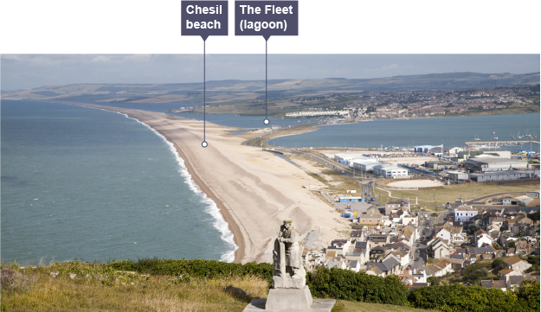
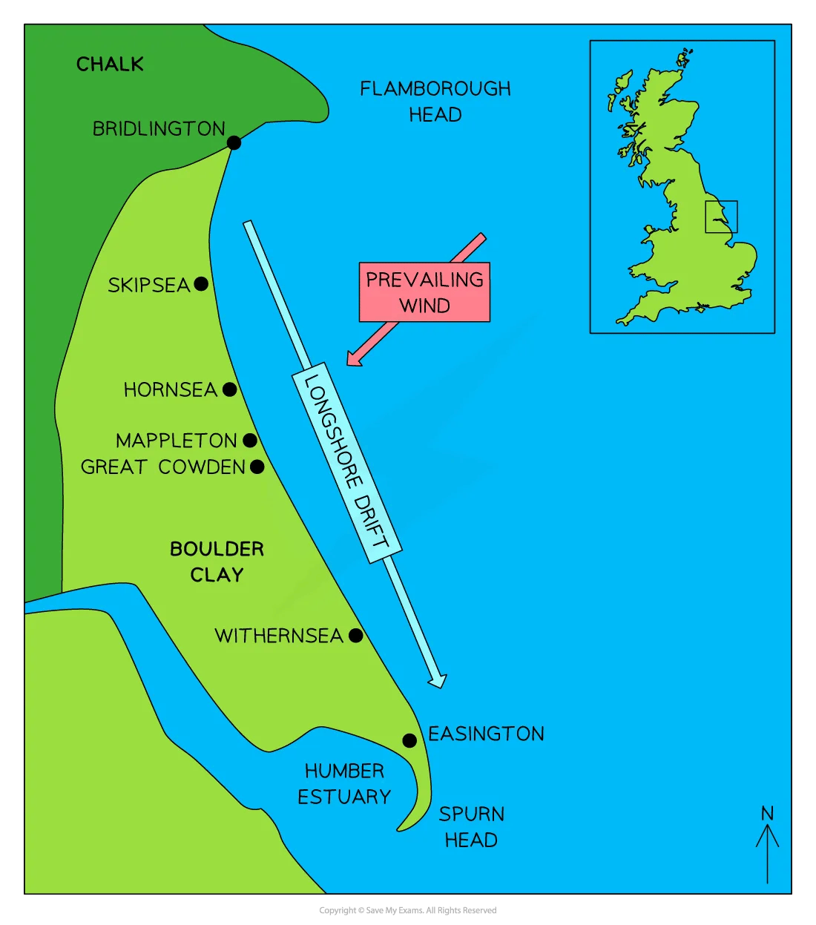
Coastal Management – Holderness Coastline, Mappleton
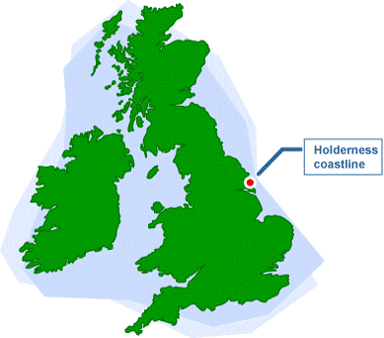

Location
Mappleton lies approximately 3km south of Hornsea on the Holderness Coast, East Yorkshire. The village of around 50 properties has been subject to intense erosion at a rate of two metres per year, resulting in the access road being only 50m from the cliff edge at its closest point. Mappleton is served by the B1242, the main road connecting settlements along the Holderness Coast.

Requirement for the Scheme
- Holderness coastline exposed to destructive waves from the North Sea.
- Mappleton is made up from boulder clay, left from the last ice age leading to rapid rates of erosion.
- Flamborough Head stops material moving down the coast, leading to smaller beaches.
- One of the fastest eroding coastlines in Europe.

The Scheme - 2 Rock groynes
- In 1991 almost £2 million was spent on two rock groynes and a rip rap to protect Mappleton (a village) and the B1242 coastal road (a key road connecting along coastline).
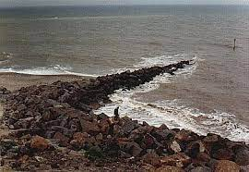
- Blocks of granite were imported from Norway for the sea defences. The purpose of the two rock groynes was to prevent longshore drift to trap beach sediment to help build larger beaches. By retaining a wide, sandy beach between the stone groynes, the sea would not reach the base of the cliffs at Mappleton. Slowing down rates of erosion. Additionally, the cliff between the two groynes is now stabilised through cliff reprofiling and the addition of vegetation cover.
- Rock armour was placed at the seaward edges of the embankment to provide extra protection.

Impacts – how successful?
Social
- The 2 rock groynes have successfully protected the local B road, ensuring travel and trade can continue.
- The 50 properties in Mappleton are now protected from the likelihood of coastal flooding due to a wider beach.
- Other areas along the coastline are not protected – farmland is devaluing and losing profits year on year as land falls into the sea as there is less sediment to stop waves.
- Increased rates of erosion in areas further down coastline such as Aldborough and Great Cowden.

Economic
- Withernsea (a seaside town further along coastline) has had to spend millions of pounds each year to protect its population due to the lack of sediment (result of 2 rock groynes preventing LSD in Mappleton).
- Properties along the Holderness coast lose their value, leaving owners in negative equity.
- Many of the other settlements rely heavily on tourism and if they are undefended their trade would diminish as facilities close down.

Environmental
- Wildlife behind Spurn Point is losing diversity as the environment cannot support many species due to the lack of sediment from longshore drift.
- Loss of habitats due to erosion.

Conflicts
- Increased rates of erosion in areas further down coastline such as Aldborough and Great Cowden and this is believed to be due to the rock groynes at Mappleton reducing sediment transportation.
- The 61km coastline has only protected higher value areas, where some are left undefended, especially areas farmland, leading to conflict with some residents.

River Tees, North East England

Location
The River Tees is in the north of England. The source of the River Tees is in the Pennines and it flows east to its mouth, where the river joins the North Sea.
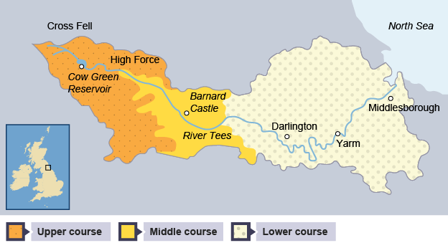

Upper Course
The upper course has hard impermeable rocks. Here, vertical erosion has formed a V-shaped valley.
High Force is in the forest in Teesdale in the River Tee’s upper course. The river drops 20m as a single sheet of water into the foaming and turbulent plunge pool below. It then continues its course through a spectacular gorge.
The waterfall was formed due to a resistant band of igneous rock (cooled volcanic lava) called dolerite, which cuts across the river valley. This has developed over hundreds of years to form High Force Waterfall.
The underlying darker rock with horizontal layers (called beds) is the carboniferous limestone.
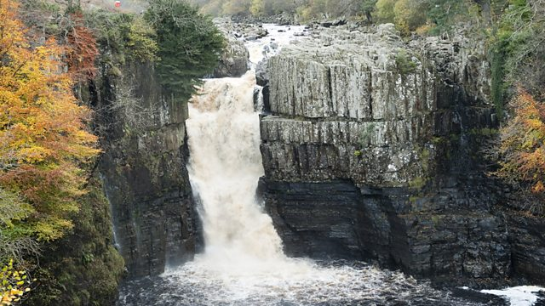
The overlaying slightly lighter coloured rock with vertical joints is the dolerite. As the river plunges over the waterfall, it undercuts the weaker limestone forming an overhang. This eventually collapses, and the waterfall gradually retreats upstream to form a gorge.
Middle Course
The River Tees flows from west to east near Darlington over relatively low-lying land in its middle course. Along this stretch of the River Tees are good examples of meanders, levees and flood plains. The meander at Sockburn is a good example.
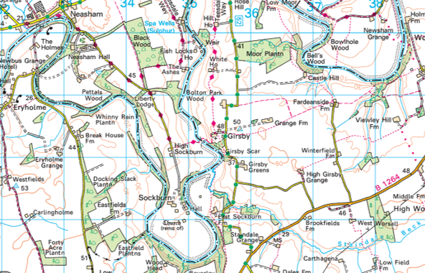

Lower Course
Near Yarm, the meanders in the lower course are much larger, and ox-bow lakes have formed. In this area there are also levees which have formed when the river has flooded.
The River Tees has a very large estuary entering the North Sea with mudflats and sandbanks which supports wildlife in the area. Sites such as Seal Sands are protected areas.

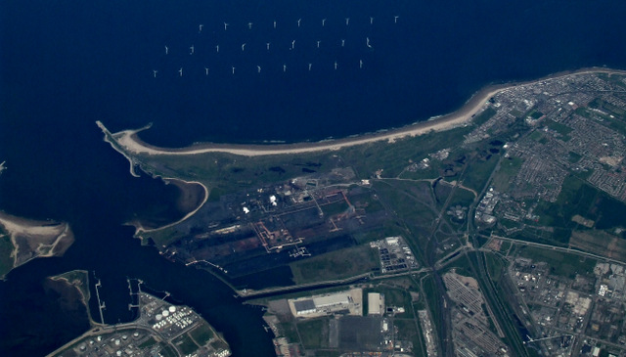
Banbury Flood Storage Reservoir, Oxfordshire, England

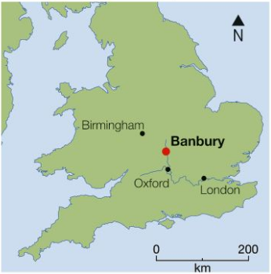
Location
Banbury is a market town in Oxfordshire with a population of around 45 000 people. It is 50 kilometres north of Oxford. Much of town in on floodplain of the River Cherwell (tributary of River Thames).

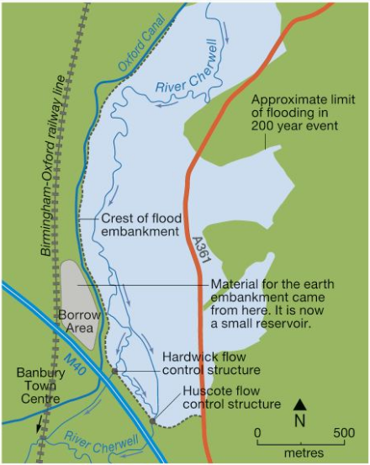

Requirement for the Scheme
Banbury has been affected by the flooding of the River Cherwell many times in the past. In 1998 serious flooding closed the railway station and caused damage in excess of £12 million. Further flooding occurred in 2007.

The Scheme
The scheme was completed in 2012. This included:
Strategy (1) – Road Raising: 860 metres of the A361 was raised in the flood storage area and culverts (small tunnels) to improve drainage beneath road to reduce flooding.

Strategy (2) – Pumping Station Built; Pumping station built at Moorfield Brook to transfer excess rainwater into the river downstream of the town.

Strategy (3) – Earth Embankments and Floodwalls: New 2m high, 400m long earth embankment to protect the industrial estate from flooding and specifically, a flood wall built around the site of prodrive (a motorsport business).

Strategy (4) – A Biodiversity Action Plan (BAP): New habitats, including ponds, trees and hedgerows provide greater interception and areas to absorb and store excess water to reduce flood risk.

Strategy (5) – Flood Storage Area: A new flood storage area has been created by building a 2.9km earth embankment parallel to the M40 – it can hold 3 million cubic metres of water (1200 Olympic size swimming pools!). On the natural floodplain, collecting rainwater that otherwise would have caused the river to swell and flood. Within the flood embankment there is a control structure with an opening which controls the rate of flow. Excess water builds up behind, filling the reservoir and protecting Banbury beyond.

Issues
Social
- Transport disruption for local people has been alleviated by raising the A361 route into Banbury.
- New footpaths and green areas have improved people’s wellbeing.
- Local people are less anxious about future flooding.

Economic
- Despite the high cost, benefits of protecting property and transport are estimated to save over £100 million.
- Reduced costs for flood damage for homeowners and transport (roads, railway station).
- Locals may receive lower insurance premiums for flood damage.

Environmental
- There was some habitat destruction in the construction of the embankment.
- Biodiversity Action Plan has resulted in planting trees and hedgerows and constructing ponds.
- Reservoir will provide a temporary habitat for water birds.
- The concrete apertures are unnatural in the landscape.

Paper 2: Living with the human environment
Section A – Urban issues and challenges
Specification | Example/Case Study
A case study of a major city in an LIC or NEE to illustrate:  The location and importance of the city, regionally, nationally and internationally  Causes of growth: natural increase and migration  How urban growth has created opportunities and challenges. | Rio- Brazil
An example of how urban planning is improving the quality of life for the urban poor in an LIC/NEE | The Bairro Project in Rio
A case study of a major city in the UK to illustrate:  The location and importance of the city in the UK and the wider world  Impacts of national and international migration on the growth and character of the city.  How urban change has created opportunities & challenges.  The effects of Urban Sprawl | London, UK
An example of an urban regeneration project to show:  Reasons why the area needed regeneration  The main features of the project. | Canary Wharf
Features of sustainable urban living:  How urban transport strategies are used to reduce traffic con | Freiburg  Transport for London.

Section B – The changing economic world
Specification | Example/Case Study
An example of how the growth of tourism in an LIC or NEE helps to reduce the development gap. | Jamaica
A case study of one LIC or NEE to illustrate:  The location and importance of the country, regionally and globally  The wider political, social, cultural and environmental context within which the country is placed  The changing industrial structure. The balance between different sectors of the economy. How manufacturing industry can stimulate economic development  The role of transnational corporations (TNCs) in relation to industrial development. Advantages and disadvantages of TNC(s) to the host country  The changing political and trading relationships with the wider world • international aid: types of aid, impacts of aid on the receiving country  The environmental impacts of economic development  The effects of economic development on quality of life for the population. | Nigeria, Africa
Impacts of industry on the physical environment. An example of how modern industrial development can be more environmentally sustainable | Car Manufacturing Industry- Nissan
Population decline & Growth | Burbage & Outer Hebrides

Section C – The challenge of resource management
Specification | Example/Case Study
An example to show how the extraction of a fossil fuel has both advantages and disadvantages. | North Sea
An example of a local renewable energy scheme in an LIC or NEE to provide sustainable supplies of energy. | Practical Action in Peru

The Challenges of Urban Areas Topic

Urban Growth in an LIC/NEE- Rio, Brazil

Population Growth of Rio
Rio’s population is rapidly growing for 2 reasons- rural to urban migration and natural increase.
Rural to urban migration occurs due to push factors:
- Poverty caused by work only being available in farming, therefore leading to land shortages so land is overused causing food shortages.
- Drought leading to famine in rural areas
- Lack of clean water in rural areas
- Little hope of change or improvement; old, traditional ways of life.

As well as pull factors;
- Opportunity of better paid jobs
- Work in factories, offices and jobs
- Reliable food supply and electricity
- Schools (help improve skills), hospitals and safe water supply
- Rio has over 1000 Primary schools and the best Universities in Brazil
- Self-help work in the informal sector often brings in more money than farming
- Life expectancy is higher in Rio compared the rest of Brazil

Cities in LIC/NEE countries also grow rapidly because of Natural Increase;
- High fertility rates (Large numbers of children per women) and an increasing life expectancy means the population of people already living in Rio is increasing. City population structures are dominated by people under 25 of child bearing age so growth will continue.

What are the Opportunities of Rio?
Employment and industry
More jobs are available in Rio than there are in the North and North East of Brazil. It is the 2nd most important industrial centre after Sao Paulo. The city provides 6% of all employment in Brazil. It also has one of the highest incomes per head in the country. Even if you don’t find work in the formal economy, paying tax. It is possible to work in the informal economy, for example as a street vendor or recycling waste, paying no tax.

Rio is the top visitor destination in South America and tourism is the city’s biggest industry. The sandy beaches of Copacabana and Ipanema, the hot sunny climate, the magnificent scenery and the spectacular annual carnival attract visitors from all over the world.

For centuries Rio was Brazil’s largest and most important city. Although Sao Paolo has overtaken it in size and population, it is still very important to Brazil. Rio’s main manufacturing industries include chemicals, pharmaceuticals, clothing, furniture and processed foods. Service industries are also very important and Rio is a major centre for banking, finance and insurance.

Land Rover has recently opened a £240 million car-manufacturing factory in Rio employing 300 people. Urban growth in the city has created many wealthy people and the company want to produce cars in Brazil for the people of Brazil.
More recently the construction industry has become a large employer due to the FIFA world cup in 2014 and the 2016 Olympic games.
Rio is also still a major port from where coffee, sugar, and iron ore are exported to all parts of the world.
Energy
In rural northern Brazil 1 in 4 homes do not have access to an electricity supply. The lowering of energy costs and building of hydroelectric power plants in Rio now means that 99% of the city has access to the power grid. The Simplicio hydroelectric complex built in 2013 supplies the city with 30% more energy. This energy is renewable and cheap allowing business, education and medicine to improve due to access to electricity and the internet.
Water
95% of the population has clean mains water supply in Rio de Janeiro compared with only 65% of the rural population. This means people are less likely to become ill from diseases and can use the water to start their own businesses e.g. hairdressers.
Healthcare
Healthcare in Rio de Janeiro has improved rapidly in comparison to other areas in Brazil. There are 105 hospitals in Rio however only 34% of these are public.
As a result of these improvements life expectancy in Rio is 77 years in comparison to a 73-year average for Brazil. Infant mortality rates are also lower, 6.2 babies die in Rio per 1000 live births compared to an average of 18 per 1000 live births for the whole of Brazil.
Education
In Brazil around 25% of the poorest children do not attend school. In Rio the illiteracy (the amount of children who can not read or write) rate is 4% while in some areas of Brazil such as Alagoas the illiteracy rate is 22%.
In Rio there are 1000 primary schools and 400 secondary schools. Rio contains 19 of the top 50 schools in the country.
The city also has 6 major universities. All of this means there are more opportunities for people to become better educated.

What are the social challenges facing Rio?
Healthcare
In 2013 only 55% of the city had a local family health clinic. Services for pregnant women and the elderly were very poor, especially in the far West Zone.
Managing Healthcare
One example of how the authorities have tried to improve health care is the in the favela of Santa Marta. Set on a steep hillside, with a population of 8,000, it has few roads and the main means of access is an overcrowded cable car. It is 13km to the nearest hospital. Medical staff took a health kit into people’s homes, and were able to detect twenty different diseases and treat them. As a result, infant mortality has fallen and life expectancy increased.

Education
Education in Brazil is compulsory for children 6-14 years. In Rio only half of all children continue their education beyond the age of 14. Many drop out of school and some get involved in drug trafficking.
The level of school enrolment in Rio is low. The main reasons for this are:
•A shortage of nearby schools in Favelas
•A lack of money and a need to work
•A shortage of teachers
Managing Education
Encouraging local people to volunteer to help in school.
Giving school grants to poor families to help meet the cost of keeping their child in school.
Making money available to pay for free lessons in volleyball, football, swimming and squash in Rochina Favela.
- Opening a private university in the Rochina Favela

Water Supply
Around 12% of Rio’s population did not have access to running water. It is estimated that 37% of water is lost through leaky pipes, fraud and illegal access. The situation has become worse in recent years.
It is estimated that 37% of water is lost through leaky pipes, fraud and illegal access.

Managing Water
Most of the Work has been on improving the quantity or quality of water in the favelas and in the Olympic Park. Seven new water treatment plants were built between 1998 and 2014, and over 300km of pipes were laid. By 2014, 95% of the population had a mains water supply.
Energy
The whole city suffers frequent blackouts due to a shortage of electricity. The growing population and the demands placed by the Olympics made the situation worse.
Many people living in the poorer parts of Rio de Janeiro get their electricity by illegally tapping into the main supply, which is risky and unsafe.
Managing Energy
The electricity supply to Rio has been improved by:
- Installing 60km of new power lines
- Building a new nuclear generator
- Developing the new hydro-electric complex which will increase Rio’s supply of electricity by 30%. It took 6 years to build and cost over US$ 2 billion.
- A biogas power plant has been set up which uses the methane gas from rotting rubbish producing enough electricity for 1000 homes.

What are the economic challenges of Rio?
Poor Tax Revenue
Due to a high level of work in the informal sector the government receives little money from people in the form of tax. As a result the government struggles and is reluctant to invest in the Favela’s particularly services which would improve quality of life and economic growth.
Informal Sector
Due to a lack of education and investment in Favelas, it has become common for people to create their own work. This is known as the informal sector. As people rely on their own motivation and creativity for work it is often low pay and unreliable. One example is collecting rubbish and taking it to the bottom of the favela to be collected.

What are the Environmental Challenges of Rio?
Air Pollution
- Air pollution is estimated to cause 5000 deaths per year in Rio!
- The city is often covered in smog due to heavy traffic and congestion as well as mist from the Atlantic mixing with car and factory fumes.
- Rio is also the most congested city in South America.
- Roads can only be built on lowland around the coast, restricting access.
- Cars have increased by 40% and many people prefer to travel by car due to high crime rates.
Management
-Coastal roads have been changed to one-way during rush hours to improve traffic flow
- The metro system has been expanded, to encourage public transport links.

How are the economic challenges being managed?
The Schools of Tomorrow programme is a charity and government led scheme to improve access to education in Favelas. In Rocinha a college has been developed to encourage more people to stay in schools past the age of 14. This would mean they are less likely to become involved in crime, but get a more reliable job in the formal sector instead. This will lead to an increase in taxpayers. The scheme also helps adults and offers course in a particular field e.g. science to help reduce unemployment. Parents can even take advantage of a nursery for young children.
Waste Pollution
- Rio de Janeiro generates more waste than any other city in Brazil, 4.1 pounds per citizen per day.
- Many of the Favelas generate large amounts of waste, which the government do not collect. This gathers polluting street and attracting vermin.
- Almost two-thirds of Rio’s waste goes to landfills to dispose of. As landfills become larger, natural areas have to be reduced and the soil in and around the landfills becomes toxic, or unable to sustain life.
Management
- A power plant has been set up using methane gas from rotting rubbish
- The new biogas power plant consumes 30 tonnes of rubbish a day and produces enough electricity for 1000 homes.
Water Pollution
- In Guanabara Bay pollution from rubbish and human waste has become a huge concern. During the 2016 Olympics people handling boats had to wear gloves and medical staff were on standby to treat infectious cuts.
- The bay has been heavily impacted by urbanization, deforestation, and pollution of its waters with sewage, garbage, and oil spills. As of 2014, more than 70% of the sewage from 12 million inhabitants of Rio de Janeiro now flows into the bay untreated.
Management
- Ships are fined for dumping fuel into Guanabara Bay illegally.
- 5km of new sewage pipes have been installed around badly polluted areas

An example of a project to improve quality of life: THE FAVELA BAIRRO PROJECT

In Brazilian cities such as Rio de Janeiro, many poor rural migrants end up living in slum settlements, known as favelas on the surrounding slopes. These are illegal settlements and not recognised as part of the city, so in the 1990’s the government decided to upgrade the favelas so that they would be official neighbourhoods.
£200 million was provided to improve 60 favelas through self-help schemes. Locals were given materials such as concrete to construct permanent houses. This meant that people living in the favelas had better housing as well as learning new skills through building the houses themselves.
A new sewage system has been built which has improved sanitation and stopped disease spreading, especially amongst children. There are also more waste bins provided and regular waste collection.
Previously residents used to tap into the electricity supply illegally, however the council has now provided them with a permeant electricity supply with underground cables installed. There is also improved education as a new school and day care centre have been built.
Today, almost all the houses in slums like Rocinha are made from concrete and brick, and have basic sanitation, plumbing, and electricity. In Rochina there are hundreds of businesses and even a McDonalds! One disadvantage though was that as the value of the improved houses increased, some residents cashed in by selling up and moving to other favelas which hadn’t yet been upgraded.
To help to deal with the current social problem, health services have been offered to people suffering from issues related to abuse, drugs and alcohol abuse.
Along side the scheme the government have introduced the role of Pacification to help reduce crime. Here the military have been entering favelas to push out gangs and drug dealers from the area. As a result many people feel safe and quality of life has improved.
The schools of tomorrow program has close links with the scheme, they have offered in particular evening classes to adults to encourage them to get qualification and start a career in a area they desire.
The Bairro Project officially ended in 2012 however many of its projects have continued to this day.

Urban Issues and Challenges in the UK — London
National Importance: Capital of the UK, wealthiest city, many universities, large range of jobs and businesses.
International Importance: Major financial centre in the world, has HQ’s of many international companies, big attractor of international investment, international airports.

Impact of National and International Migration:
London is the most culturally diverse city in the UK, 37% of the population were born outside of the UK, and less than half are white-British.
Cultural diversity has created opportunities in entertainment e.g. Notting Hill Caribbean Carnival.
Areas like Shoreditch have developed due to cultural diversity, young professionals due to national migration has led to trendy bars, cafes and galleries.
Signs are written in different languages to help migrants. There is also an array on multi faith buildings e.g. Mosques.
There is some issues with racial abuse, less access to education, and ethnic segregation. Language barriers in schools is also a problem.

Social Challenges:
Education: There are many of the best schools in England in London, but also a lot of underperforming schools
Health: Not all areas of the city have equal access to healthcare, with resulting variances in life expectancy between rich and poor areas. Old industrial areas have poor health due to poor diets etc.
Housing Inequalities: House prices are greater than anywhere else in UK, there is also a shortage of good quality and affordable housing. People pay high prices for run down homes.
Urban Deprivation: there is a contrast in wealth, life expectancy, exam results and employment levels/income between areas in London, e.g. Chelsea compared to Newham.

Economic Challenges caused by population increase:
Areas of old heavy industry (London Docklands) went into decline from 1970’s.
Income inequality with 21% of people are paid below the London living wage, and many people at the opposite end of the scale.
Increased migration has led to an increase in house prices. This has pushed poorer people out of their neighbourhoods.
Traffic congestion cost London businesses £3 billion in 2018

Environmental Challenges caused by population icrease:
Urban Sprawl (Green Belt): increase pressure to build houses on this land as its cheaper and the demand for housing is high. Towns surrounding London are also experiencing growth into their green belts as a result of the housing shortage.
Dereliction: as manufacturing has declined much land has been left to go derelict creating a spiral of decline and pollution.
Air Pollution: mainly created by vehicles and industry. Regularly breaks EU regulations on air quality on nitrous oxide levels. Trying to encourage use of public transport and cycling.
Waste Disposal: Most waste is recycled but 1/4 still goes into landfill which produces methane and some water pollution into rivers. Aim is for landfill to become zero by 2030.
Greenfield Sites: land is cheaper to build here and no need to demolish buildings, but creates loss of habitats and valuable farmland.
Brownfield Sites: Some need to be decontaminated from previous industrial use, but the land is often expensive as in the city, but does help reduce urban sprawl.

Social Opportunities created by migration and regeneration:
Large cultural diversity for things like food, music and religion.
Huge variety of sporting events, theatres, museums, cinemas etc.
Unique industries e.g. film and fashion.
New developments e.g. Canary Wharf have provided new houses, shopping and job in the financial industry for local people.

Economic Opportunities creating by new transport development and migration:
There are large job opportunities in the service sector especially finance, but also areas of regeneration have created many new jobs.
London has an integrated transport network which makes it easier to get around especially for workers and businesses.
London is one of the most visited places in the world, so has huge tourism potential.

Environmental opportunities created by environmental laws (urban greening):
47% of London is green space (one of the world’s greenest cities), with many parks such as Hyde Park.
Having green space helps combat Co2 levels, trees reduce flooding risks, important habitats, and help with peoples health.

Regeneration of Canary Wharf & Sustainable Urban Living
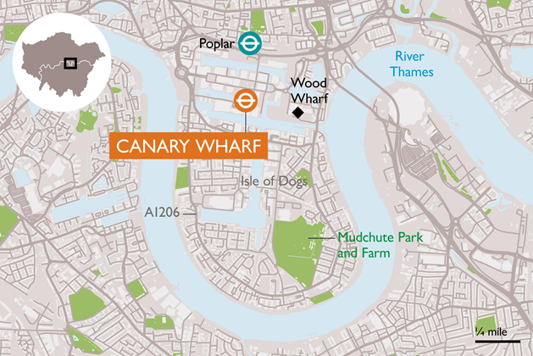
Regeneration began in the 1980s. The area (previously known as the London docks) had been in decline since the 1950’s. This is because larger ships could no longer access the port. Unemployment soared, the back to back terraced housing fell into disrepair and there was a lack of transport and leisure facilities. The area became the first Enterprise Zones in 1981. The land was made rate free for ten years.
Between 1981-1998 many changes occurred within London Docklands, costing around £2 billion. For example:

What did the regeneration involve?
Employment
The area transformed into the financial district of London attracting many headquarters of TNCs, businesses, banking and service industries. This created 100,000 jobs.
Housing
Many of the former warehouses have been transformed into luxury flats. This is an example of gentrification. Low-cost housing has also been built along with the renovation of older council-owned properties.
Leisure
A large shopping area was constructed close to Canary Wharf. A number of parks have been created where buildings once stood. More recently the Millennium Dome was built in this area.

Transport
London’s Docklands now has its own light railway. The Dockland Light Railway (DLR) connects with Bank and Monument underground stations. This makes travel into the City of London very easy.

Urban deprivation has greatly reduced in the area due to new and improved housing, including council and housing association properties for those who need financial support. The development and investment of new industries in retail, leisure, finance and technology have led to an increase in employment and average income. The respective unemployment rates were 17.8% in 1981 and 7.2% in December 1997. Transport has also improved with the Dockland Light Railway, quickly connecting Canary Wharf to other parts of London. This has therefore improved access to wider services such as healthcare and jobs.

Sustaimable Urban Living - FMaking Urban
Sustainable Urban Living – Freiburg
Freiburg is a city in Southwest Germany
In 1970 the local government set the goal of complete urban sustainability. There are several reasons why this decision was taken:
- Freiburg has one of the youngest populations in Germany who advocated for the environment in many protests
- The old town is cobbled, which reduces traffic in the city already
- The city is situated in the Black Forest which holds cultural importance.
- 9 month protest in 1975 showed how passionate the local residents are about protecting their environment
- Most of the area was reduced to rubble during bombings associated with WW2, meaning there was an opportunity to rebuild a more sustainable future.
Today:
- Groups of people, including children, give feedback and offer their opinion on all new city developments, such as new building construction. There are incentives for locals who invest in environmental projects
- The city plans to be 100% renewable energy powered by 2035.

How is Freiburg Sustainable?
Transport
Freiburg's urban development plan places significant emphasis on non-motorised modes of transport, namely cycling and walking. To encourage these sustainable practices, the city has:
- Electric trams are the most frequent public transport, in the busiest areas they are no more than 4 minutes apart on each route
- Cyclists have priority and designated lanes to improve safety and makes travelling by bike around the city faster than cars. There are twice as many bikes than cars on Freiburg!
- Created traffic-calmed zones and pedestrian precincts in the city centre and neighbourhoods, making walking a more enjoyable and practical mode of travel.
- One car parking space permit for a year costs over £20,000 to reduce the number of cars used in the city.
- One bus ticket can be used an unlimited number of times per day to anywhere in the city to speed up public transport & encourage people to use it.
The combined effect of these measures has been an increase in the number of people choosing to cycle or walk as their main mode of transport, thereby lowering traffic congestion and contributing to a reduction in air pollution levels.
Energy
Freiburg's strives to be using 100% renewable energy by 2035. As one of the sunniest places in Germany, Freiburg already relies upon solar energy, alongside wind energy. Vauban is a city district in Freiburg where the majority of homes run on solar energy, mainly using rooftop solar panels.
Biomass provides the
largest proportion of
renewable energy in
Freiburg through the
use of rapeseed oil and
wood.
Buildings in Freiburg are also subject to strict standards to reduce energy consumption and
save as much energy as possible. Buildings are installed with the latest energy efficient technologies. Due to energy efficient homes now being the standard, most homes actually create more (solar) energy than they use, which is returned back to the city grid and can be used to fuel the public lighting/transport.
Water
A sustainable water supply requires individuals to use as little water as possible. It involves collecting and recycling water rather than relying on only freshwater from reservoirs. Home roof gardens are essential for rainwater harvesting. These are referred to as “green roofs,” which among other things, capture rain water that is then re-used. Furthermore,
residents have grey water systems which recycle bath, sink and washing machine water. This results in savings of 70L+ of water per person per day.
Waste recycling
The city recycles more than 88% of waste.
350 community collection points established for recycling.
Within apartment blocks, there are shared pantry’s that residents can use to share food they might waste and support their neighbours. This also reduces the food waste for each block
Green space
Freiburg has over 600 hectares of parks and 160 playgrounds providing greenery, recreation, and biodiversity. Pesticides are not used in management of plants, and only indigenous trees and shrubs are planted. 22,000 trees were planted in the parks, and the same number along streets. There are also 3,800 small gardens on the outskirts of Freiburg, that serve as a source of fresh fruits and vegetables.
In total 40% of the city is forested, reducing soil erosion as well as proving habitats
Economic sustainability
This refers to maintaining a strong economy. Many jobs have been created in green industries, which employ around 10,000 residents. For example, a large cluster of solar panel manufacturers is based in Freiburg, contributing to its nickname, the ‘solar valley’, which employs over 1000 locals. This has led to a stable and thriving economy for the city. Businesses in the area are responsible for fines if they exceed certain environmental policies.
Green space
- Freiburg has over 600 hectares of parks and 160 playgrounds providing greenery, recreation, and biodiversity.
- Pesticides are not used in management of plants, and only indigenous trees and shrubs are planted.
- 22,000 trees were planted in the parks, and the same number along streets.
- There are also 3,800 small gardens on the outskirts of Freiburg, that serve as a source of fresh fruits and vegetables.
- In total 40% of the city is forested, reducing soil erosion as well as proving habitats

Water
A sustainable water supply requires individuals to use as little water as possible. It involves collecting and recycling water rather than relying on only freshwater from reservoirs.
- Home roof gardens are essential for rainwater harvesting. These are referred to as “green roofs,” which among other things, capture rain water that is then re-used.
- Furthermore,
- residents have grey water systems which recycle bath, sink and washing machine water. This results in savings of 70L+ of water per person per day.
Energy
Freiburg's strives to be using 100% renewable energy by 2035. As one of the sunniest places in Germany, Freiburg already relies upon solar energy, alongside wind energy.
- Vauban is a city district in Freiburg where the majority of homes run on solar energy, mainly using rooftop solar panels.
- Biomass provides the largest proportion of renewable energy in Freiburg through the use of rapeseed oil and wood.
- Buildings in Freiburg are also subject to strict standards to reduce energy consumption and save as much energy as possible. Buildings are installed with the latest energy efficient technologies.
- Due to energy efficient homes now being the standard, most homes actually create more (solar) energy than they use, which is returned back to the city grid and can be used to fuel the public lighting/transport.
Waste recycling
The city recycles more than 88% of waste.
350 community collection points established for recycling.
Within apartment blocks, there are shared pantry’s that residents can use to share food they might waste and support their neighbours. This also reduces the food waste for each block
Economic sustainability
This refers to maintaining a strong economy. Many jobs have been created in green industries, which employ around 10,000 residents. For example, a large cluster of solar panel manufacturers is based in Freiburg, contributing to its nickname, the ‘solar valley’, which employs over 1000 locals. This has led to a stable and thriving economy for the city. Businesses in the area are responsible for fines if they exceed certain environmental policies.

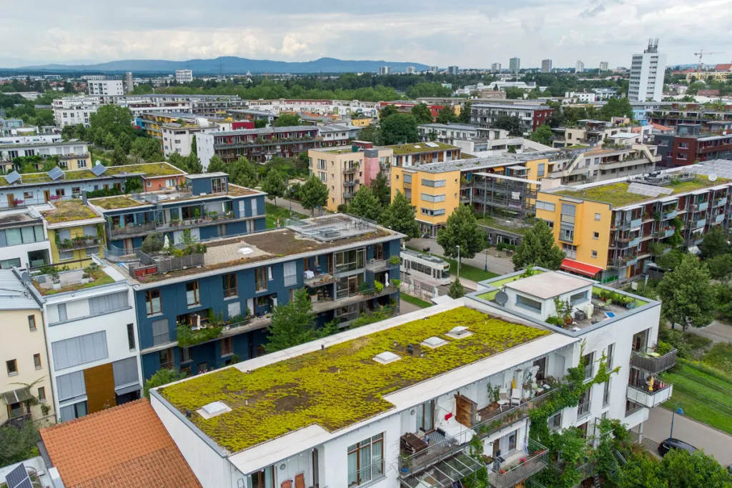
Economic sustainability
This refers to maintaining a strong economy. Many jobs have been created in green industries, which employ around 10,000 residents. For example, a large cluster of solar panel manufacturers is based in Freiburg, contributing to its nickname, the ‘solar valley’, which employs over 1000 locals. This has led to a stable and thriving economy for the city. Businesses in the area are responsible for fines if they exceed certain environmental policies.
Waste recycling
- The city recycles more than 88% of waste.
- 350 community collection points established for recycling.
- Within apartment blocks, there are shared pantry’s that residents can use to share food they might waste and support their neighbours. This also reduces the food waste for each block.
Transport more Sustainable- Transport for London.
The congestion Charge
In 2003 the congestion charge was introduced to key zones within the capital. This was later extended to the west on London in 2007.
Those who choose to drive through these zones on a week day are charged a toll. This idea was proposed to Manchester in 2008 but they rejected it.
On a smaller scale bus lanes have been used to encourage public transport use instead.
A payment of £11.50 is required each weekday from 7am – 6pmfor each vehicle which travels within each zone.
If payment is not made you face a fine from £60 - £180. This method has been successful as London has seen a 26% drop in congestion since its introduction.
How is it effective?
The scheme made £122 million in 2005/6 which has largely been reinvested in improving bus services around the capital.
Road accidents have also decreased with some zones seeing a 70% decrease in road accidents.
Issues
As many people who commute in and around London are wealthy the cost has not really put people off driving through London and as a result there is still an issue with congestion.

The Elizabeth Line
First called the London Cross Rail, the new Elizabeth line runs from Reading through West London all the way to the East. The rail development was approved due to the poor transport links between West and East London.
How is it effective?
The scheme has reduced the time it takes commuters to travel across London, improving efficiency and pressure on other public transport systems. The new rail network is predicted to reduce the number of cars on the road, easing congestion in and around London.
Issues
As the development is new, there seems to be some teething issues with trains braking done due to electrical faults.

The Santander Scheme
Originally nicknamed the “Boris Bikes” after the start up of Boris Johnston during his time as London Mayor, the scheme was created to reduce CO2 and ease congestion on London’s roads and other public transport.
The bikes can be accessed from a variety of different stations across the city centre using a credit card. The cost is £2 to access a bike and have 30mins riding time. After this there is a £2 pound charge for every 30 minutes.
How is it effective?
They are economically sustainable as most can assess and afford to use the scheme. They also allowed people to explore the city at their own leisure and can make good use of the cycle lanes around London avoiding traffic and congestion. They are also environmentally sustainable as they release zero CO2 reducing smog and the contribution to global warming.
Issues
Each bike station only has a limited amount of parking points meaning that if full people have to search for other stations that may have a free space. This may be a particular problem if you are in a large group. Also the bikes are in one size and so not child friendly.

Economic Development Topic
Jamaica – an example of tourism to reduce the development gap
Jamaica is an island in the Caribbean Sea within the Tropics. It is located close to other major islands such as Cuba. It has mass tourism because many people visit every year (1.3 million people in 2001). People visit for the beaches such as Montego Bay, deep sea fishing at Port Antonio, caves at Cockpit County, golf courses such as next to Kingston Town and water sports in Montego Bay. More cultural activities include various historic plantation houses such as at Port Maria and there are environmental tourist attractions such as bird sanctuaries inland from Montego Bay and Botanic Gardens and a National Park in the Blue Mountains. Jamaica does have problems however, because its tourism numbers are declining slightly due to competition from new resorts across other Caribbean Islands. Mass Tourism also brings problems and positives to the Island.
POSITIVES
Tourism brings in money to Jamaica – 20% of its GDP – this money can be spent on essential services such as health care and education which can boost the overall level of development. This does have a downside however, as Jamaica is dependent upon this income and if tourist numbers fall the economy would be affected.
220,000 Jamaicans work in tourism – it is a vital employer. People work in a wide range of jobs, from the construction of hotels and tourist facilities, to service work cleaning, working in bars, caddying on golf courses amongst other jobs. Tourism benefits many sections of the economy as people spend money in bars, restaurants, and other local businesses, so tourism has a positive multiplier effect.
NEGATIVES
Many of the jobs created are seasonal, so people can become unemployed
Large TNCs (Trans National Companies) such as Thomas Cook organise the holidays and make most of the money, so the profits go out of Jamaica and into HICs Local employees are paid low wages, whereas managers from other countries tend to earn more.
There is cultural pollution/dilution; Jamaica has a problem with sex tourism and a problem with drugs. Land for the massive hotels takes away land from famers. Water use also increases for drinking water, washing and recreation, taking water from local people. Local people cannot afford the facilities put in place for the tourists. As a response to some of the problems and in an attempt to become more sustainable, Jamaica is branching tourism out into community tourism were tourists stay with locals in their homes, directly benefitting locals, and ecotourism, in the inland area of the Blue Mountains with low densities and tourist lodges.

Newly Emerging Economy — Nigeria
Importance:
Supplies 2.7% of the world’s oil (12th largest producer)
Largest population in Africa, provides a large workforce and market.
Many Nigerians live around the world.
Provides soldiers to the UN peacekeeping forces.

Political, Social, Cultural & environmental context:
Gained independence from the UK in 1960. Had a relatively stable government since 1999, but there is still some conflicts in the north.
There is corruption, especially in the oil industry.
It is a multiracial society, with many different religions (Christian south and Muslim north).
Considerable poverty in the country. Infant mortality is 18 times higher than the UK, literacy rate is 61%, and GNI is only 15% of the UK. Approx. 70% of the population live in poverty.
Nigerian music, cinema, literature and sport spread through Africa and the world.
In the semi-arid north it makes for difficult living conditions. The centre of the country has a cooler and wetter climate there is a lot of farmland. In the south there is a lot of rainforests and plantations.

Changing Industrial Structure:
Traditionally traded in agricultural products (still important), but the discovery of oil led to this industry to be developed (91% of exports).
Most people still work in agriculture and 25% in oil.
Exports are mostly raw materials, which have a low value.
Manufacturing is slowly increasing, which is increasing jobs, and earning higher wages.
Growing opportunities to the global finance and IT sector.

The role of TNC’s:
Nigeria is attractive to TNC’s from China, USA, South Africa due to political stability, large cheap workforce and raw materials.
Shell attracted to Nigeria due to finding of oil. It brought in a lot of tax and export money, employed 65,000 people and developed linked industries. Tax has help the gov improve services such as healthcare and education which has improved literacy rates and life expectancy. However 60% still live in poverty.
There are issues with oil spills which have contaminated the environment and destroyed habitats. Polluted water has also put farmers out of business and made women infertile.
Nestle have moved their due to Shell’s success and took advantaged of the area to grow palm oil. Although this has led to deforestation.

Changing Political and trade relationships:
Member of the commonwealth and involved in many African organisations such as African Union, oil politics and also the UN.
Imports most goods from China, EU and USA such as phones and refined oil (petrol/diesel).
Exports mostly to EU, USA and India which are mainly raw materials such as oil, cotton and rubber.
Doesn't tend to trade much with African countries.
International Aid:
Is a relatively wealthy country but has many poor people, so does receive international aid to tackle issues such as clean water, education & healthcare.
Still receives £300 million a year from the UK to help improve public services. Also receive 60 million mosquito nets from the USA as the countries has the highest date rates from Malaria than anywhere else in the World.
Environmental Impacts:
Smaller industrial companies are not scrutinised as much as the large ones, so there is often a lot or land, air and water pollution.
Oil industry is guilty of this with oil spills polluting fishing areas and farmland. Companies having to pay compensation to local people and clean it up.
Deforestation as farmland urban areas expanded which has reduced biodiversity and land degradation.
Quality of Life:
There is a slow improvement for the average Nigerian as life expectancy has increased, mortality rate has fallen, safe water access has increased and enrolment in secondary education has doubled.
HDI has increased from 0.466 in 2005 to 0.514 in 2014.
However the number of health staff has levelled off and access to sanitation has fallen. This caused by rapidly increasing population, and oil wealth not been sued properly.
The effects of industry in the UK on the Environment- Nissan in Sunderland
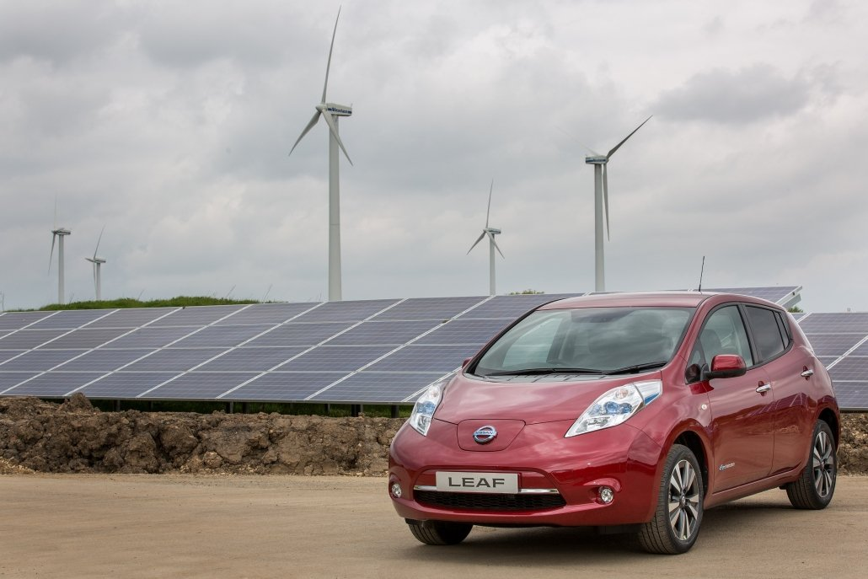
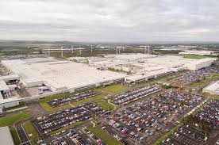

The North East has continued to be an industrial hub for the secondary (manufacturing) industry regardless of the effect caused by deindustrialisation. However slowing metal works, chemical plants and other manufacturing plants are closing down.
One that currently still exists today is the Nissan plant in Sunderland. This plant employs 7000 people in the area.
Environmental Issues | Reducing these issues
- Car manufacturing was not sustainable in the past due to inefficient engines producing toxic pollutants.  - Parts were difficult to recycle.  - The production of vehicles was a energy-intensive production processes. Requiring an increased use of fossil fuels. | - The site has 10 wind turbines generating 6.6MW and 19,000 photo-voltaic panels (solar panels). This equates to 7% of the plant’s electrical requirements, enough to build 31,374 vehicles.  - CO2 levels have been reduced by 22.4% since 2005.  - Nissan is developing electric and hybrid cars.

An example of population growth and decline in rural areas.

Dealing with the North South Divide
Improving transport/infrastructure
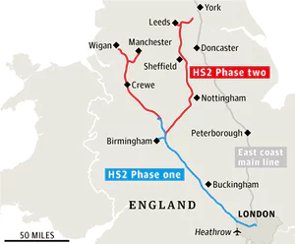
Government Incentives
The government has offered tax reductions and site developments have been offered in the north east to attract investment from TNCs.

HS2 is the most current approach to help bridge a divide between the North and South.
Its estimated to cost over £100 billion however its believed that it will generate £40 billion worth of investment and economic growth through job opportunities and development in the north.
The increased amount of rail passengers will also make rail more sustainable.
Many people do not approve of the transport as it will affect many rural areas. Also many northern cities will not benefit as they won’t have a station.
Changes to HS2 – T
The train lines to Leeds and Manchester have now been scrapped and the line will only travel to Birmingham. This will reduce the scheme’s impact of reducing the N/S divide, as it will only go to the midlands.

City Deals

27 northern towns and cities have been given extra powers in planning and transport. £7 billion has been promised to help make the changes. Canary Wharf was a successful example of this in the south.

Enterprise zones were areas in the north where planning regulations were less strict, investment in superfast broadband was made and land was regenerated by governments to attract investment. One example was Salford, Manchester.
Enterprise Zones
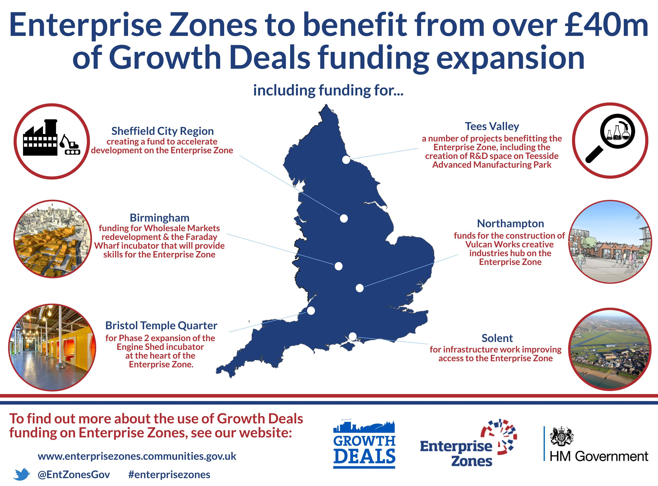

An example to show how the extraction of a fossil fuel has both advantages and disadvantages: North Sea Oil & Gas

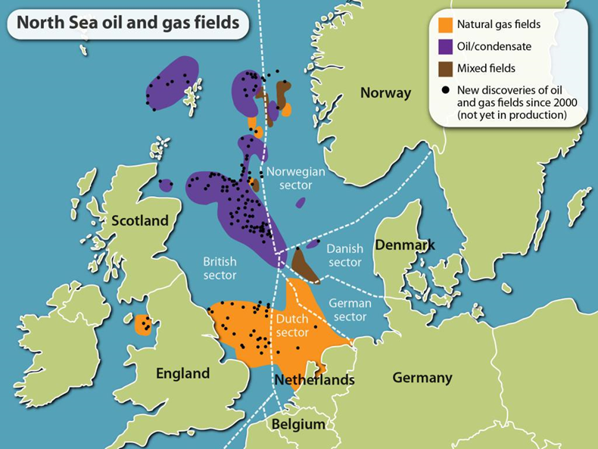
The North Sea is rich in both oil and gas fields. Part of the territory is classed as British waters and it’s here where the UK can access its own reserves through drilling.
Oil- Advantages
Exploiting offshore oil creates lots of jobs as people are needed in the offshore process. This has really boosted places like Aberdeen as people have moved there to take part in the oil industry. Unemployment is down to 1%.
Having access to its own oil increases the UK’s energy security and means we do not have to rely on other countries.
Disadvantages:
The reserves of oil and gas are starting to dwindle (more than 50% has been extracted) and the oil and gas is tougher to extract due to conditions.
Oil leaks can create huge environmental effects, killing wildlife. In 2011 it’s estimated that 1300 barrels of oil were spilled into the sea near Aberdeen.

An example of a local renewable energy scheme in an LIC or NEE to provide sustainable supplies of energy- Practical Action in Peru
The steep slopes and narrow valleys are ideal for HEP as they can be dammed and the rapid flow of water ensures the generation of electricity. Melting snow provides a surplus of water, but this varies throughout the year. In 2009 the El Platanal HEP power plant began generating electricity as part of the Practical Action Program.

The microfinance scheme allows small communities to invest in the technology to generate electricity from the local rivers. The scheme has allowed small communities to have access to electricity for the first time. As well as providing jobs running the machinery, the access to electricity has improved education by allowing schools to access the internet and up to date resources. Farmers can increase their milk production by using machinery rather than by hand. Also the milk can be kept cool.

Medical care has also improved as medicine can be kept cool and therefore medicines can be stored that couldn’t be before. This has led to an improvement in health and quality of life.

Other local people have been able to improve their quality of life by starting their own businesses such as radio stations. This has led to a secure income and improvement in diet, happiness and connections to the outside world.

The scheme overall has rapidly improved the development of Peru, farming is large scale and more economically rewarding and education is increasing the future careers and industry prospects for the people. Poverty and deprivation is being reduced.

